**ACTIVITY QUILTS FOR ADULTS**

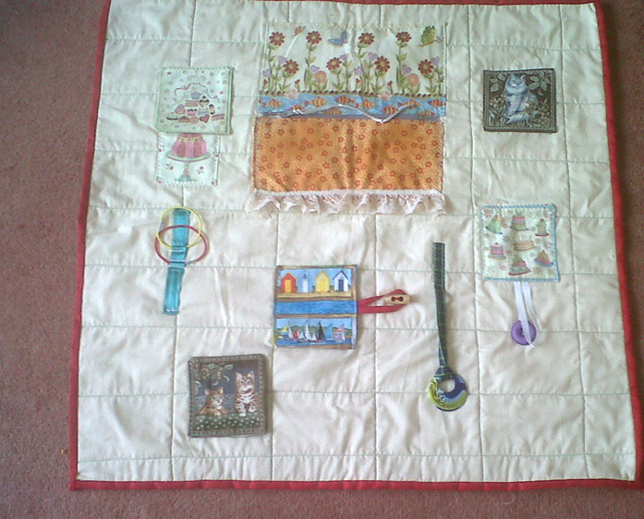

When a person has dementia they may become very bewildered about their environment and often become agitated and begin plucking at their clothing. These quilts enable them to be distracted and provide a constructive activity.

The aim is to maintain finger skills with buttons, zips, ribbons and Velcro and provide stimulation and conversation topics.

The quilt must be firmly sewn to enable frequent washing.

Finished size approx.. 22” x 22” (56cm x 56cm)

Requirements:

1 fat quarter – these are squares of fabric available from shops which sell patchwork items and are usually good quality cotton fabric.

1 fat quarter of fleece

Themed blocks 6 – 8

Themed decorations to include zip, button, Velcro, cord, ribbon etc.

Method:

1. Attach the fat quarter to the fleece and stitch together firmly in a 2” (25mm) square grid
2. Add themed blocks. These should be reversible with tabs on bottom. They should be attached along the top edge of each themed block only.
3. Provide a tactile panel. This can be chenille or textured fabric or washable, crinkly material between layers eg. foil lined, crisp packet.
4. Add a block about 8” square with a zip in the middle and sewn all around thus making a pocket
5. Velcro can be attached to lower edge of tabs
6. Add ribbons/cords. They can be incorporated by affixing very firmly to either the background fabric or a themed block eg. tails on dog fabric, maximum length 5”
7. Bind finished mat with double binding and ensure all stitching is secure.

*These quilts can be donated to hospitals and care homes where they can be used to help those suffering from dementia and also people recovering from a stroke.*

